Grid User Network Interface (GUNI)

Draft Version 0.9.2

Grid High Performance Networking Research Group | University of Essex  Georgios Zervas  Eduard Escalona  Reza Nejabati  Dimitra Simeonidou
GRID WORKING DRAFT | NXW  Nicola Ciulli  Gino Carrozzo
draft-ggf-ghpn-GUNI-0.9.1 | PSNC  Artur Binczewski  Damian Parniewicz  Bartosz Belter
Category: Informational Track | FHG  Wolfgang Ziegler  Oliver Waeldrich
http://forge.gridforum.org/projects/ghpn-rg/ | MCNC  Gigi Karmous-Edwards
Alcatel-Lucent
Dominique Verchere
SJTU
Wei Guo

Contents
1 Introduction 3
1.1 Draft’s objectives 3
1.2 Current standardization of User Network Interface 3
1.2.1 OIF UNI 1.0 4
1.2.2 OIF UNI 1.0 R2 4
1.2.3 OIF UNI 2.0 5
1.2.4 IETF GMPLS UNI Model 5
1.3 OGF and OASIS standardization considerations 6
1.3.1 WS-Agreements 6
2 GUNI role and activities in Grid Network Environment 7
2.1 GUNI definition 7
2.2 GUNI role and activities 8
3 General Requirements 11
3.1 Telcos’ requirements and considerations 12
4 Architecture and Functionalities 13
4.1 GUNI Architecture 13
4.1.1 GUNI Overlay Model 13
4.1.2 GUNI Integrated Model 14
4.2 Services offered over the GUNI 15
4.2.1 Network services offered over GUNI 15
4.2.2 Grid services offered over GUNI 17
4.3 Policy and Security 17
5 Abstract messages and procedures 18
5.1 Network Service (NS) abstract messages 20
5.2 Grid Network Service (GNS) abstract messages 22
5.3 Procedures 27
6 Use cases 30
6.1 GMPLS 30
6.2 Network Resource Provisioning Systems (NRPS) 31
6.3 Grid-enabled GMPLS (G²MPLS) 31

Introduction
The technological evolution shapes the promise for a new technological era and an emergent roadmap to the Grid Networking infrastructure which drives the need for the support of number of distinct layered architectural models across geographical organizational boundaries, heterogeneous environments with different policies, service provisioning systems, control and transport planes as well as security standards.

This document proposes a standard set of functionalities of a Grid User Network Interface (GUNI) to serve distributed heterogeneous, dynamic Grid network environments. The GUNI will act as a Grid network service control interface between Grid users/applications/resources and Network Provisioning Systems (e.g., GMPLS, NRPS, Control Plane). The goal of this work is to describe GUNI requirements driven from use cases and in turn provide specific capabilities that meet these requirements. The various functionalities required to support Grid services and applications will also be determined. Key to the realization of this standardization vision is to embrace the OGF standards and provide enhancements to already defined UNI standards (OIF, IETF).

Draft’s objectives
The drafts’ envision is to define and describe the requirements, functionalities and procedures of a generic interface – GUNI – between the Grid Service Layer and the Network Service Layer. This draft will report the role and activities of GUNI in Grid-Network environments. Different usecases are considered and abstract messages are used to address possible solutions for the design of a common interface.

Current standardization of User Network Interface

OIF UNI 1.0
Within the Optical Internetworking Forum (OIF), the User Network Interface (UNI) [ref OIF-UNI-1.0] and External Network Node Interface (E-NNI) [ref OIF-E-NNI-Sig-01.0-rev1] are necessitated interfaces to develop interoperable procedures for requesting and establishing dynamic connectivity across heterogeneous networks defined by the automatic switched transport network (ASTN) [ref ASTN].

UNI is defined as the service control interface between the user devices and the transport network equipment from different vendors. It addresses the definitions of connectivity services offered by the transport network, the signalling protocols used to invoke the services, the mechanisms used to transport signalling messages, and the auto-discovery procedures that aid signalling. OIF UNI 1.0 is scoped to allow an early implementation based on reusing existing signalling protocols and auto-discovery mechanisms taking into consideration work of other standards bodies such as IETF’s [ref] proposed standards. It is a result of cooperation between network and equipment vendors to improve carriers’ ability to provide new services while reducing operating cost. OIF UNI 1.0 scope is only on the signalling for service invocation. Routing, reachability, and address resolution protocols are outside the scope. It particularly focuses on the ability to create and delete point-to-point transport network connections on-demand including bandwidth, signal type, and routing constraints (diversity). OIF UNI 1.0 also specifies methods for neighbour and service discovery, provides policy and security considerations. UNI signalling can be between the network elements. It is also possible for one or both of them to be represented by a proxy.

OIF UNI 1.0 R2
The second implementation agreement (IA) is an update of UNI 1.0 addressing mainly extensions to RSVP-TE signalling protocols [OIF-UNI-1.0-R2-SIG]. Two more IAs the CDR-01 and the SEP-0.1.1 have been released to support OIF UNI 1.0. The first one outlines Call Detail Records (CDR) for OIF UNI 1.0 Billing as an agreement on CDR procedures and formats to allow both carriers and suppliers to capture usage records on optical connection thus offering usage-based billing optical services [From August 12, 2002 OIF press release]. On the other hand, OIF-SEP-0.1.1 is focused on Security Extensions for UNI and NNI in order to provide a common set of security mechanisms required to protect the UNI signalling control channel(s).

OIF UNI 2.0
OIF work has been continued towards UNI 2.0. OIF UNI 2.0 definition is planning to include OTN and Ethernet connections. The notable features under consideration of UNI 2.0 include separation of Call and Connection Control, sub STS-1 Rate Connections, transport of Ethernet services, transport of G.709 interfaces and enhanced security. UNI 2.0 will follow the call and connection architecture from ASON as described in [ITU-T G.8080] and [G.7713].

The UNI could legitimately be extended in a number of other dimensions. Within the OIF, for example, proposals have been made to allow the client to specify the routing to use and to pass some topology information from the network to the client. The applications in mind were for a private UNI (in the sense discussed above). A limited NNI capability, suitable for a "private NNI" such as might be needed for a L1 VPN, was identified as an application of this sort of UNI.

IETF GMPLS UNI Model
IETF GMPLS defines both routing and signalling protocols for the creation of Label Switched Paths (LSPs) in various transport technologies [ref]. It is mentioned that in overlay model, the core-nodes act more as a closed system. The edge-nodes do not participate in the routing protocol instance that runs among the core nodes; in particular, the edge-nodes are unaware of the topology of the core-nodes. There may, however be a routing protocol interaction between a core-node and edge-node for the exchange of reachability information to other edge-nodes. On the other hand in peer model, edge-nodes support both a routing and a signalling protocol. The main focus of the IETF GMPLS UNI is the RSVP-TE procedures between edge-node and core-node in the overlay model [ref].

OGF and OASIS standardization considerations
GUNI role in Grid networking community is influenced by OGF, OASIS and OIF standardised documents and implementation agreements. WS- Resource Framework (WSRF) under OASIS together with OGF standardised documents like WS-Agreements, GLUE schema, JSDL and UNI1.0 R.2 of OIF are considered. GUNI role in Grid networking community is influenced by OGF, OASIS and OIF standardised documents and implementation agreements. WS- Resource Framework (WSRF) under OASIS together with OGF standardised documents like WS-Agreements, GLUE schema, JSDL and UNI1.0 R.2 of OIF are considered.

WS-Agreements
Today it is common practice to use Service Level Agreement (SLA) in grid resource management. SLAs provide a flexible way to describe desired services, their properties, rewards (penalties) for successful (unsuccessful) service provisioning, and the guarantees that must be met in order to fulfil service requirements. Furthermore, SLAs provide a domain independent way to describe atomic services such as resource reservation services, as well as complex services like co-allocation services.
The Web Service Agreement specification of the Open Grid Forum (OGF) became a standard way within the grid community to use SLAs. Therefore, the WS-Agreement specification defines a term language to express the different aspects of a service level agreement and a protocol to create SLAs based on templates and to monitor the state of the SLAs and of the given guarantees. Below there is a list and a brief description of the common features that atomic and complex services should provide over GUNI.
- Definition of Reservation Times:
Compute services that support advance reservations may expose this functionality by using SLAs. Services that support advance reservation of resources expose a special guarantee term in the agreement template.
- Restriction and Validation of SLA Offers:
Besides describing a service and the associated guarantees, it is also important to define the structure and the value facets of a valid SLA offer.
- Negotiation of agreement templates:
In a co-allocation process scheduling services need resource availability information of the involved systems in order to efficiently calculate a common reservation time. In order to co-allocate this type of resources, negotiation mechanisms are required
- Agreement creation:
After the negotiation of an agreement template, a client may want to create an according agreement. The scheduler first negotiates a set of templates with the providers and identifies the possible reservation times of the required resources.

GUNI role and activities in Grid Network Environment

GUNI definition
GUNI aims to interface users/applications which are able to take advantage of Grid resources (computers, instruments, sensors, data resources), network resources (bandwidth, wavelengths, switches, ports), and storage resources with network provisioning systems in a joint and seamless way.

GUNI intends to interface Grid users directly or indirectly (e.g. via Grid Middleware) to the appropriate network provisioning systems. Different types of services such as resource discovery, characterization, reservation, allocation, and management services need to be supported. Furthermore, accounting, billing, service level agreement, and security must be redefined to support the Grid Infrastructure. All of the above issues must be addressed by protocols and mechanisms that build an architectural model. This document provides a generic definition of the GUNI to support any type of global Grid Network architecture.

GUNI role and activities
Interoperable procedures are required for requesting and establishing dynamic network (via Network Provisioning Systems (NPS)) and non-network services (via Grid Middleware) between clients, applications and computational resources (e.g. CPUs, storage, etc.), all connected by the transport network. Grid User Network Interface (GUNI) comprises a number of procedures to facilitate on demand as well as in-advance access to network services to handle/interoperate with the NPS. Interoperable procedures between Grid users/resources (e.g. storage, processor, memory) and transport network for agreement negotiation and Grid service activation have to be developed. The GUNI reference point acts as the interface between Grid End Points and the NPS as shown in Figure 1.
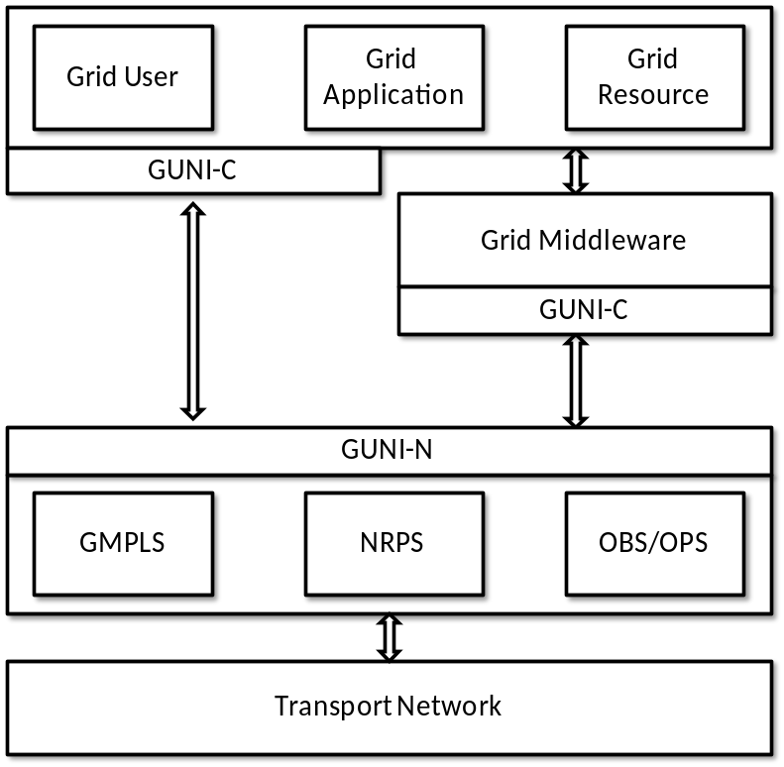
Figure 1: GUNI Positioning on Grid Network Environment
The development of interoperable GUNI procedures for requesting and establishing dynamic network services between Grid clients/applications requires the definition of an enhanced User to Network interface able to support:
- connectivity services through the transport network for Grid end-points,
- protocols used to invoke the network services,
- auto-discovery procedures.
All these procedures facilitate on demand as well as in-advance network services requests. The abovementioned description constitutes the Grid User Network Interface (GUNI).

GUNI activities listed and described below represent the functionalities supported by GUNI in a very abstract way:

Network Activities
  - Connection establishment
  - Connection deletion
  - Status exchange
  - Network auto-discovery
  - Use (traffic)
The specification of these activities under the Network service cluster is provided by OIF UNI standardization document [ref]. For each activity, there is Grid Layer – Network Layer role. The first five activities are specified in OIF UNI as User – Server roles (instead of Grid Layer – Network Layer roles). GUNI enhances Activity 1 by implementing advance reservation as an extra feature of connection establishment (Table 1).
Network Activities
1 | 2 | 3 | 4 | 5
Grid Layer | Grid Layer | Grid Layer | Grid Layer | Grid Layer
Connection Establishment | Connection Deletion | Status  Exchange | Auto  Discovery | Use
Network Layer | Network Layer | Network Layer | Network Layer | Network Layer
Table 1: GUNI Network Activities

General Requirements
GUNI architecture and functionalities are depended on a number of requirements that are especially important in a large-scale, distributed Grid network environment. Requirements may be functional and non-functional and are driven by the use cases.

- Extensibility: GUNI architecture needs to scale to potentially support any possible Grid network service provisioning system or in general IT service provisioning systems from application layer down to physical layer.

- Interoperability: GUNI must be able to interface to any software, hardware and service boundaries between different layers (e.g. middleware and NPS):
  - Grid Users/Resources
  - Grid Middleware
  - NPS (NRPS/GMPLS/...)

- Performance and agility: GUNI should dynamically adjust the service provisioning level (e.g. Bandwidth provisioning) and accept different signal types and levels of granularity.

- Support of Service Oriented Architectures (SOAs):
  - Escalation of topology/resource abstraction

- QoS assurance:
  - Service Level Agreement
  - Migration
  - Reliability

- Security and Policy: GUNI should provide means to check and forward service credentials for using grid and network resources and accounting for the real resource usage.
  - Authentication and authorization
  - Multiple security infrastructures
  - Perimeter security solutions
  - Isolation
  - Delegation
  - Security policy exchange
  - Intrusion detection, protection, and secure logging

- Flexibility
- Failure notification

Telcos’ requirements and considerations
From Telco’s perspective, it is interesting if network services can be part of bundled service elements to automate service management and business level agreements without exposing network operator infrastructure information. This can be achieved by considering network resources as elements of Grid Services creating virtual network configurations. However, the network resources abstraction needs to be limited to avoid automation problems such as a complex network planning or scheduling.

Architecture and Functionalities

GUNI Architecture
GUNI must provide a general and open definition in order to support different architectural models. However, the information exchanged northbound and southbound is architecture dependant. The basic architectural model can be identified as Overlay Model, which refers principally to the positioning between the Grid Service layer (client) and the Network Provisioning System layer (server).

GUNI Overlay Model
Under the Overlay GUNI model clients are unaware of the underlying network resources and the network is unaware of the Grid resources so GUNI client just requests for network resources. Co-allocation and resource management are carried out in the upper layers whereas connectivity management is carried out by the Network Provisioning System. In this case GUNI accepts connection requests from the Grid MW and establishes a new session with the NPS entity.
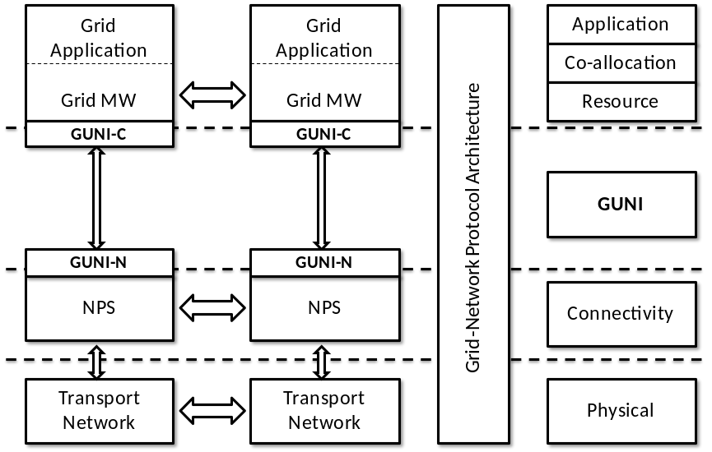
Figure 2: GUNI Overlay Model

Services offered over the GUNI
Services offered over GUNI are based on the ones already standardized in OIF UNI documents [1.0, UNI-01.0-R2, 2.0] extended to support the requirements for next generation networks. Network services basically refer to on-demand and in-advance connections, given specific parameters such as bandwidth, ingress and egress access points.
Signalling over the OIF UNI is used to invoke services that the transport network offers to clients. The purpose of the UNI is to specify interoperable procedures for requesting and establishing dynamic connectivity across heterogeneous networks, focusing primarily on the ability to create and delete on-demand point-to-point transport network connections according to bandwidth, signal type and routing constraints. These connections can be SONET services of payload bandwidth STS-1 and higher, or SDH services of payload bandwidth VC-3 and higher whereas their properties are negotiated during the connection establishment phase.
The procedures involved through the GUNI for the invocation of transport network services comprise three basic actions:
- Connection creation:
Permits the creation of a connection under specific network constrains and security procedures.
- Connection deletion:
Identifies the disposal of an existing connection.
- Connection status enquiry:
Represents the exchange of specific connection attributes allowing the connection status discovery.
Furthermore, the following supported procedures, inherited from UNI 1.0 and UNI 2.0 and further extended here, should also be offered across the GUNI:
- Network Topology Enquiry and Restoration:
GUNI must be able to provide network topology information to Grid users/services and implement various protection and restoration schemes to deal with the diverse nature of transport network failures.
- Network Resource Capability:
In order to support different bandwidth demands for Grid users and services GUNI should introduce flexible allocation mechanisms providing multiple wavelengths, single wavelength or sub-wavelength bandwidth.
- Network Resource Availability:
All available network resources (i.e. amount of bandwidth, links, cross-connects etc.) should be discovered by the GUNI and facilitated to GUNI clients.
- Network Advance Reservation:
Through automatic service discovery GUNI will provide users the capability to automatically schedule, provision and set-up paths across the network, facilitating thus network advance reservations.
- Traffic classification and shaping:
GUNI should be able to map user data traffic into the used transmission entity (e.g. timeslot, wavelength etc.) performing traffic classification and aggregation.
- Data plane enhanced security:
A security mechanism able to support security credentials and policy information provided by any agreement provider will be facilitated by the GUNI.
GUNI should be responsible for providing on-demand access to Grid services by encompassing the interoperable procedures between Grid users and the transport network.

Policy and Security
Both network and Grid services are subject to policy based access control that includes both Authentication (AuthN) and Authorisation (AuthZ). AuthN is typically defined by user client software and AuthZ is more application specific and allows using application specific/defined policy. It is also required that AuthZ can be done only for authenticated user. It is important to notice that although Grid Security Infrastructure (GSI) and Grid middleware can provide extended functionality for secure user admission and job submission, it also suggest existence of local/internal to the resource, access control service, in our case Network Element with the GUNI front-end at least providing relevant policy enforcement mechanism that enforce upper layer Grid middleware AuthZ decisions at the resource level.

Abstract messages and procedures
GUNI abstract messaging is described in this section. These messages are denoted “abstract” since the actual realisation depends of the protocol used. In the description below, terms “initiating GUNI-C” and “terminating GUNI-C” are used to identify the entities at the two end of a GNS service that initiate and terminate a given action. The initiating GUNI-C for a given action needs not necessarily be the GUNI-C that originally requested the GNS service. For example, the initiating GUNI-C for a GNS service and connection is different from the initiating GUNI-C for the original GNS service and connection request. The following abstract messages are currently defined.
Message No. | Abstract Message Name | Message Direction
 | NS Create Request | G.OUNI-C ➔ G.OUNI-N  G.OUNI-N ➔ G.OUNI-C
 | NS Create Response | G.OUNI-N ➔ G.OUNI-C  G.OUNI-C ➔ G.OUNI-N
 | NS Create Confirmation | G.OUNI-C ➔ G.OUNI-N  G.OUNI-N ➔ G.OUNI-C
 | NS Delete Request | G.OUNI-C ➔ G.OUNI-N  G.OUNI-N ➔ G.OUNI-C
 | NS Delete Response | G.OUNI-N ➔ G.OUNI-C  G.OUNI-C ➔ G.OUNI-N
 | NS Status Enquiry | G.OUNI-C ➔ G.OUNI-N  G.OUNI-N ➔ G.OUNI-C
 | NS Status Response | G.OUNI-N ➔ G.OUNI-C  G.OUNI-C ➔ G.OUNI-N
 | NS Notification | G.OUNI-N ➔ G.OUNI-C
 | Network resource availability | G.OUNI-N ➔ G.OUNI-C
 | Network topology information | G.OUNI-N ➔ G.OUNI-C
 | Network end-point assigned addresses (TNAs) | G.OUNI-N ➔ G.OUNI-C
Table 2: GUNI Abstract Messages
Table 2 depicts messages related to network reservation establishment, and service discovery. The Overlay Model should be interoperable between domains supporting different NPSs.
A list of GUNI attributes is associated with each GUNI message; some are mandatory for a given message and some optional. All these are described in the following sections.

Network Service (NS) abstract messages
The first eight abstract messages listed on Table 2 represent the standardised messages described in [OIF-UNI1.0R2-COMM] where the more generic term “Network Service (NS)” appears there as “Connection”. To avoid repetition of already standardised messages only a brief description is provided here. Attributes of the messages are described in [OIF-UNI1.0R2-COMM].
- The NS create request is used by Client (Grid MW) to request a connection between specified source and destination clients (Grid user/applications/resources). The NS Create Request is sent from:
  - The initiating GUNI-C to GUNI-N to request the creation of a connection;
  - The GUNI-N to the terminating GUNI-C to indicate an incoming connection request.
- The NS create response is used to acknowledge the establishment of the NS (connection) to the GUNI-C that initiated the NS request. The corresponding client may then start transmission of data on the established connection. The NS create Response is sent from:
  - The terminating GUNI-C to GUNI-N to accept or reject an incoming NS create request;
  - The GUNI-N to the initiating GUNI-C to indicate the success or failure of the NS requested previously.
- The NS create confirmation is used to acknowledge the establishment of the NS (connection) to the GUNI-C that terminated the connection create request and after that the corresponding client may start transmission of data on the established connection. The NS create confirmation is sent from:
  - The initiating GUNI-C to GUNI-N to acknowledge completion of the connection establishment;
  - The GUNI-N to the terminating GUNI-C to indicate that the connection has been successfully created and that the corresponding client may start transmitting data over the connection.
- The NS delete request is used to indicate the deletion of a connection. If the NS (connection) deletion is being initiated by a GUNI-C, then this GUNI-C should maintain the connection control stat and the corresponding client should maintain the data plane until after the NS deletion has been acknowledged. This avoids alarms being generated by the client at the other end of the connection. The GUNI-C terminating the NS deletion request may delete the NS state upon receipt of the NS delete request. The network may also delete an NS (a forced deletion) due to internal network failures or GUNI-N timeout of a deletion response. In that case a NS delete response is not required and the GUNI-N may terminate all NS control state and the data path. The NS delete request is sent from:
  - The initiating GUNI-C to GUNI-N to delete a NS;
  - The GUNI-N to the terminating GUNI-C to indicate deletion by other end;
  - The GUNI-N to a GUNI-C to indicate the deletion of a connection by the network.
- The NS delete response message signals the completion of the NS deletion procedure. The NS delete response is sent from:
  - The terminating GUNI-C to GUNI-N to acknowledge an incoming NS delete request;
  - The GUNI-N to the initiating GUNI-C to indicate the successful deletion of the NS as requested.
- The NS status enquiry is used to query the state and attributes of a given NS. The NS status enquiry is sent from:
  - The initiating GUNI-C to GUNI-N to enquire about the status and/or attributes of the NSs owned by GUNI-C or from GUNI-N to GUNI-C.
- The NS status response returns the status of the specified NS and associated attributes. The NS status response is sent from:
  - The GUNI-N to the GUNI-C and vice versa to indicate the status of NS attributes as requested before.
- The NS notification message is sent autonomously by a GUNI-N to either GUNI-C to indicate a change in the status of the connection.
- The Network Resource Availability is used to provide information of network resource availabilities to Grid MW and make it aware of current recourse status. This way Grid MW has the ability to calculate an end-to-end path and can be provided to Grid MW that can support such function. The Network Resource Availability is sent from:
  - The GUNI-N to GUNI-C indicates the current status of network availability to GUNI-C towards Grid MW.
- The Network Topology Information is used to provide limited and virtualised topological information of transport network environment. NPS has the authority to provide any topological information to Grid MW and this can be based upon SLA agreements. The Network Topology Information is sent from:
  - The GUNI-N to GUNI-C indicates the current status of network availability to GUNI-C towards Grid MW.
- The Network End-point Assigned Addresses (TNAs) are used to provide network end point information from GUNI-N to GUNI-C. This information is the minimum level of information that must be passed from NPS to Grid MW. The Network End-point Assigned Addresses (TNAs) message is sent from:
  - The GUNI-N to GUNI-C indicates the transport end-point information to GUNI-C towards Grid MW.

Procedures
GUNI messages contain are used to create or release Network Service (NS) requests. The network is assumed to provide coordination of signalling information between the initiating and the terminating side of the NS creations.

To create a Network Service (connection), GUNI-C sends an NS Create Request message to its adjacent GUNI-N. After transportation of the message over the network, GUNI-N sends back an NS Create Response message to the initiated G.OUNI-C. When the NS Create Response message is received then the NS (connection) within the transport network can be assumed to be established. At that time source client can start sending data whereas the destination client can only send data when it receives an NS Create Confirmation message initiated by the source G.OUNI-C. Figure 3 shows the timing diagram and message flow during successful NS creation.
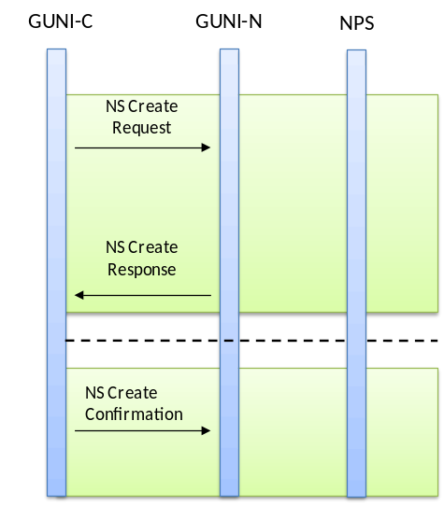
Figure 3: Successful Network Service Establishment
An NS may not be successfully created due to resource unavailability, policy or reachability constrains which is depicted in Figure 4.
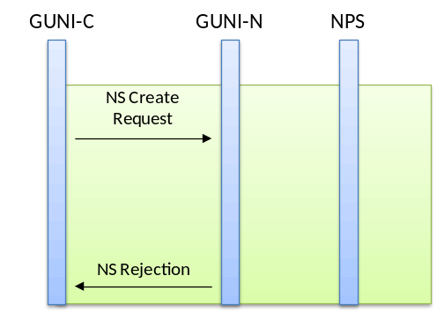
Figure 4: NS rejection by the Network
NS deletion procedure follows on the next figure which represents connection teardown initiated by the Source GUNI-C.
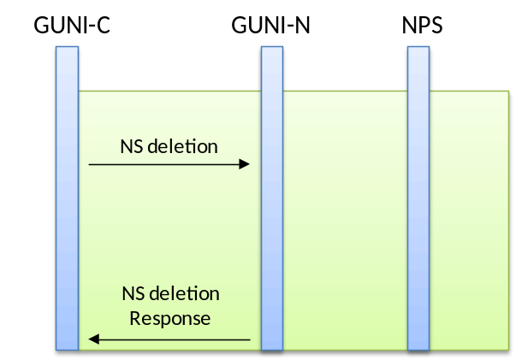
Figure 5: NS deletion initiated by the Source GUNI-C

Use cases

GMPLS
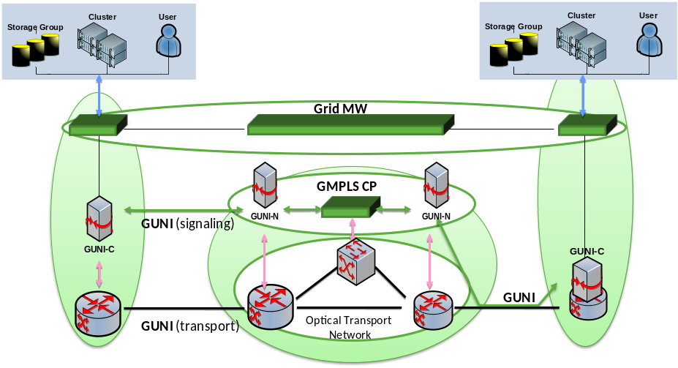
Figure 6: GMPLS Use Case

Network Resource Provisioning Systems (NRPS)
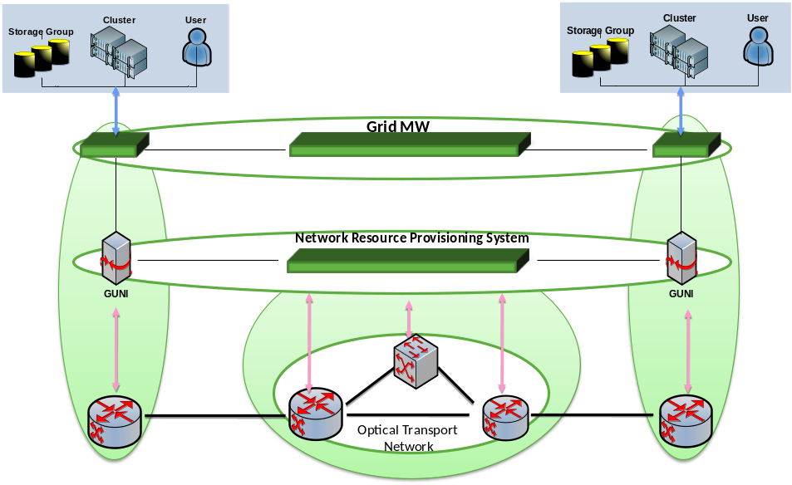
Figure 7: NRPS Use Case

Grid-enabled GMPLS (G²MPLS)
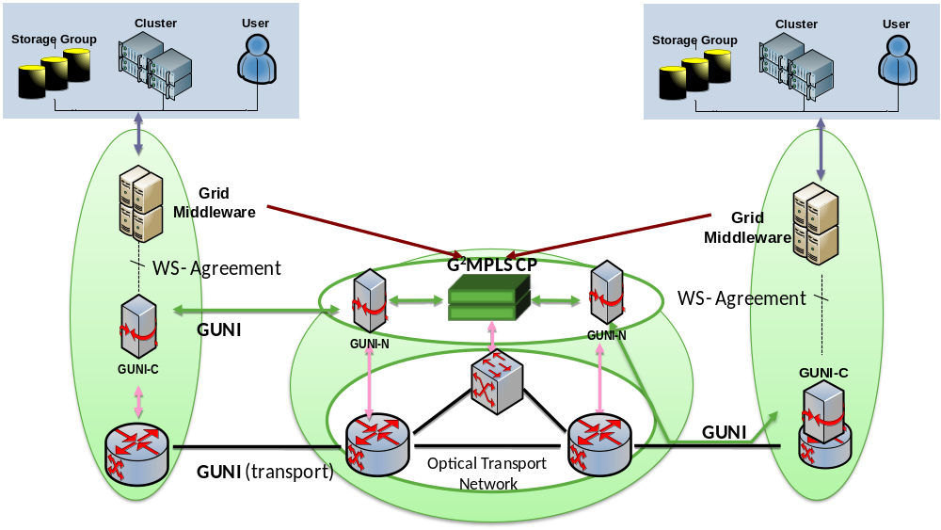
Figure 8: G²MPLS Use Case

